**STUDENT NAME: P. HASINI**

**REG NUMBER : 192111535**

**SUBJECT NAME : OPERATING SYSTEM WITH DESIGN PRINCIPLES**

**SUBJECT CODE : CSA0470**

DAY 2 PROGRAMS(SEP 27,2022)

**1.PROGRAM**

#include<stdio.h>

int main()

{

int count,j,n,time,remain,flag=0,time_quantum;

int wait_time=0,turnaround_time=0,at[10],bt[10],rt[10];

printf("Enter Total Process:\t ");

scanf("%d",&n);

remain=n;

for(count=0;count<n;count++)

{

printf("Enter Arrival Time and Burst Time for Process Process Number %d :",count+1);

scanf("%d",&at[count]);

scanf("%d",&bt[count]);

rt[count]=bt[count];

}

printf("Enter Time Quantum:\t");

scanf("%d",&time_quantum);

printf("\n\nProcess\t|Turnaround Time|Waiting Time\n\n");

for(time=0,count=0;remain!=0;)

{

if(rt[count]<=time_quantum && rt[count]>0)

{

time+=rt[count];

rt[count]=0;

flag=1;

}

else if(rt[count]>0)

{

rt[count]-=time_quantum;

time+=time_quantum;

}

if(rt[count]==0 && flag==1)

{

remain--;

printf("P[%d]\t|\t%d\t|\t%d\n",count+1,time-at[count],time-at[count]-bt[count]);

wait_time+=time-at[count]-bt[count];

turnaround_time+=time-at[count];

flag=0;

}

if(count==n-1)

count=0;

else if(at[count+1]<=time)

count++;

else

count=0;

}

printf("\nAverage Waiting Time= %f\n",wait_time*1.0/n);

printf("Avg Turnaround Time = %f",turnaround_time*1.0/n);

return 0;

}

**OUTPUT**

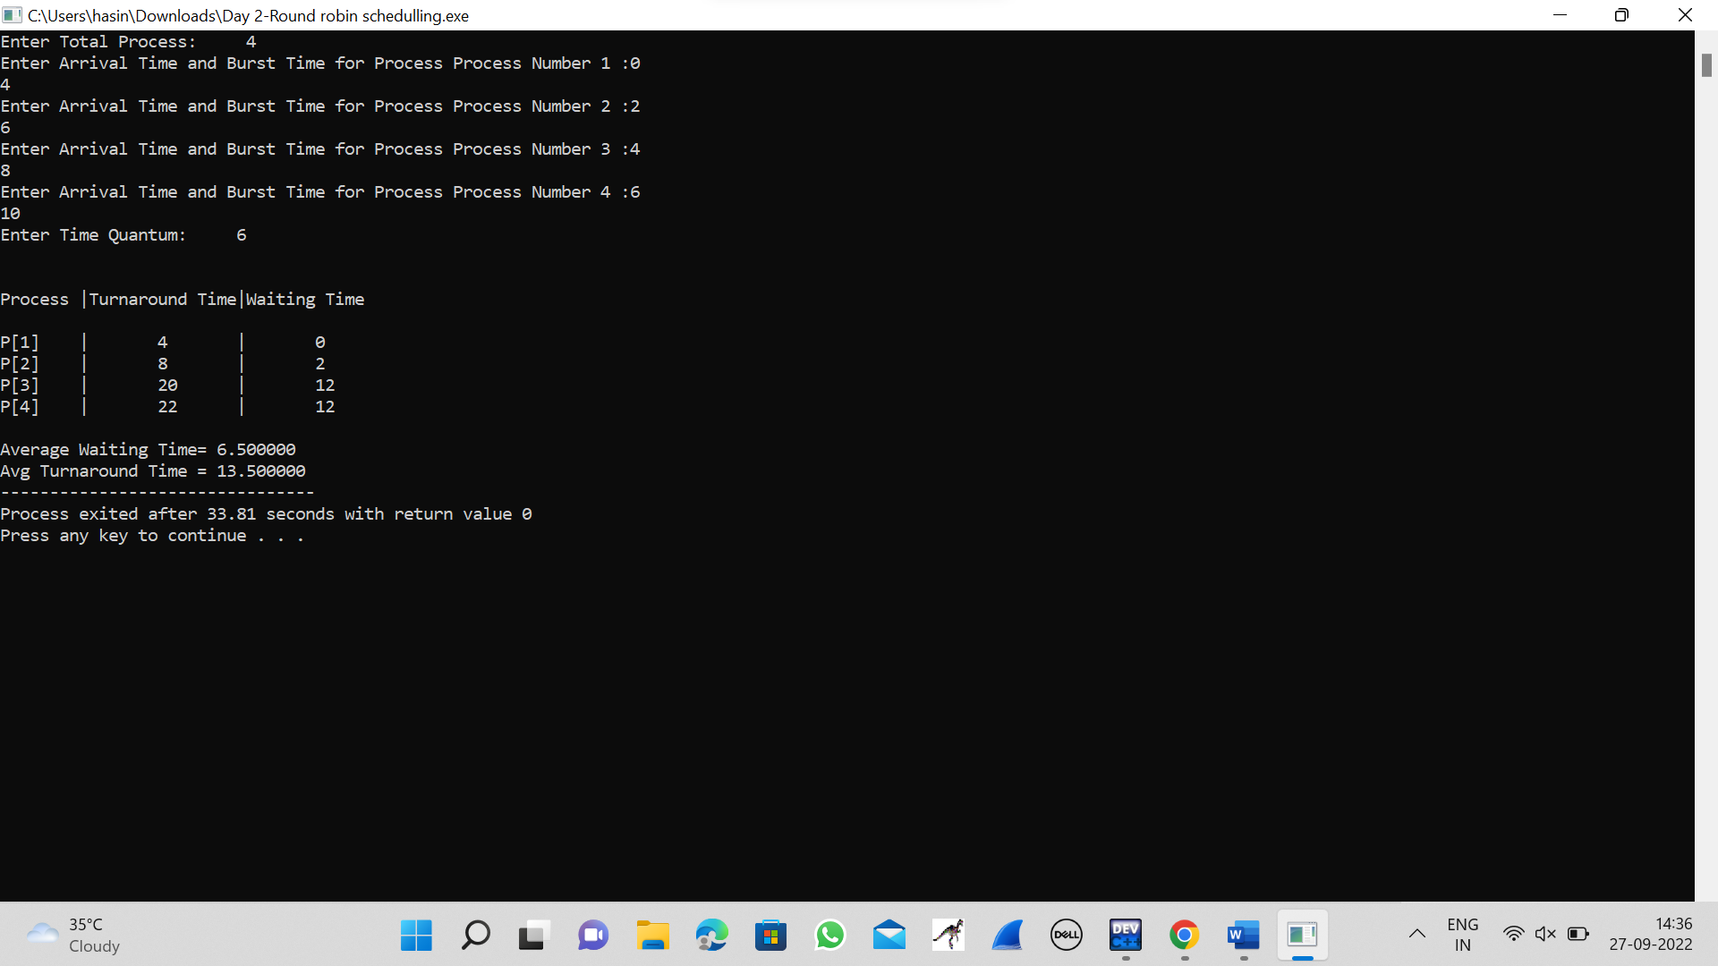

**2.PROGRAM**

#include<stdio.h>

#include<stdlib.h>

#include<unistd.h>

#include<sys/shm.h>

#include<string.h>

int main()

{

int i;

void *shared_memory;

char buff[100];

int shmid;

shmid=shmget((key_t)2345, 1024, 0666|IPC_CREAT);

printf("Key of shared memory is %d\n",shmid);

shared_memory=shmat(shmid,NULL,0);

printf("Process attached at %p\n",shared_memory);

printf("Enter some data to write to shared memory\n");

read(0,buff,100);

strcpy(shared_memory,buff);

printf("You wrote : %s\n",(char *)shared_memory);

}

**OUTPUT**

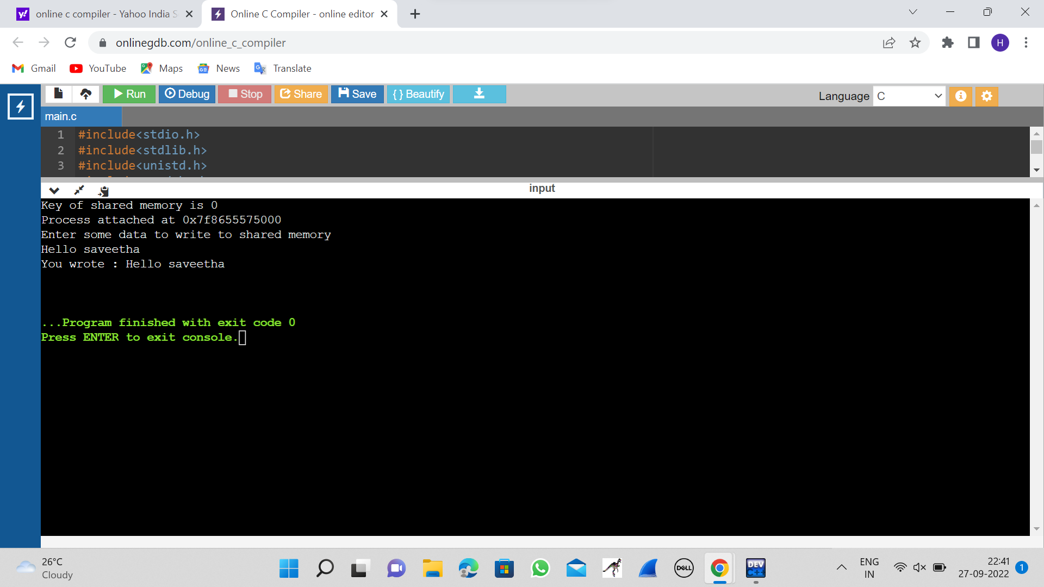

**3.PROGRAM**

#include <stdlib.h>

#include <unistd.h>

#include <pthread.h>

void *myThreadFun(void *vargp)

{

sleep(1);

printf("Printing GeeksQuiz from Thread \n");

return NULL;

}

int main()

{

pthread_t thread_id;

printf("Before Thread\n");

pthread_create(&thread_id, NULL, myThreadFun, NULL);

pthread_join(thread_id, NULL);

printf("After Thread\n");

exit(0);

}

**OUTPUT**

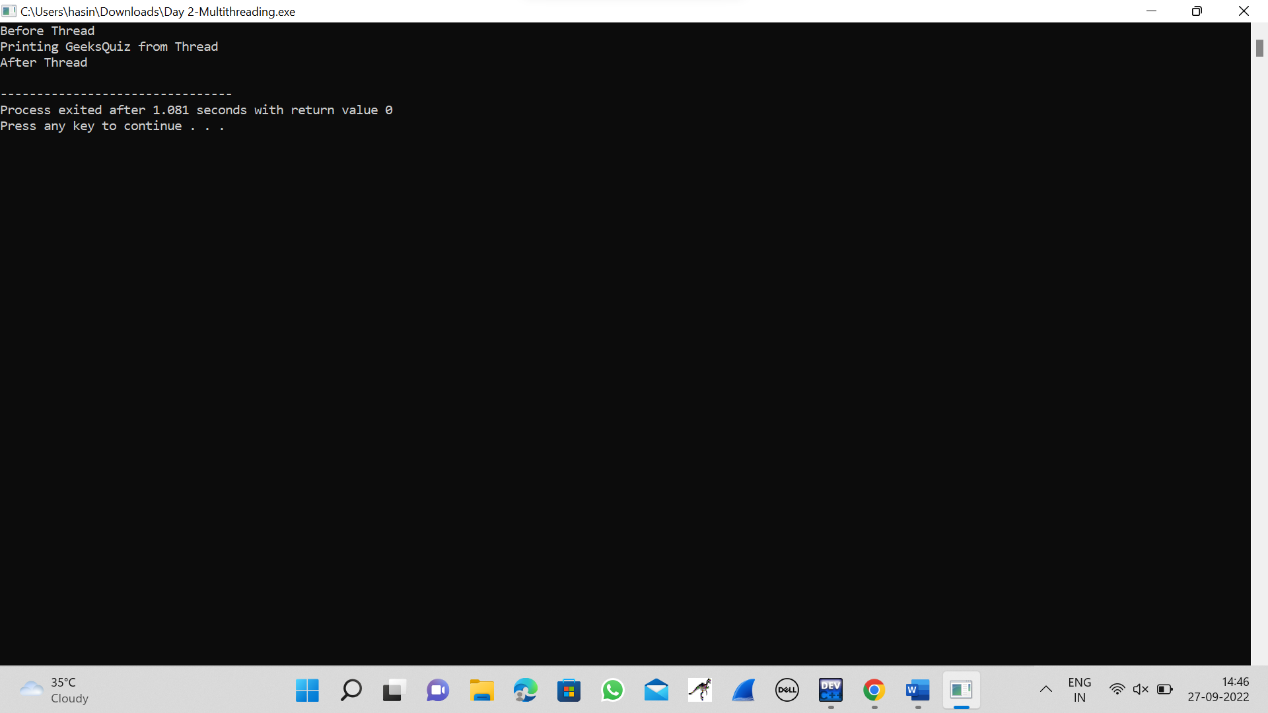

**4.PROGRAM**

#include<stdio.h>

#include<stdlib.h>

#include<pthread.h>

#include<semaphore.h>

#include<unistd.h>

sem_t room;

sem_t chopstick[5];

void * philosopher(void *);

void eat(int);

int main()

{

int i,a[5];

pthread_t tid[5];

sem_init(&room,0,4);

for(i=0;i<5;i++)

sem_init(&chopstick[i],0,1);

for(i=0;i<5;i++){

a[i]=i;

pthread_create(&tid[i],NULL,philosopher,(void *)&a[i]);

}

for(i=0;i<5;i++)

pthread_join(tid[i],NULL);

}

void * philosopher(void * num)

{

int phil=*(int *)num;

sem_wait(&room);

printf("\nPhilosopher %d has entered room",phil);

sem_wait(&chopstick[phil]);

sem_wait(&chopstick[(phil+1)%5]);

eat(phil);

sleep(2);

printf("\nPhilosopher %d has finished eating",phil);

sem_post(&chopstick[(phil+1)%5]);

sem_post(&chopstick[phil]);

sem_post(&room);

}

void eat(int phil)

{

printf("\nPhilosopher %d is eating",phil);

}

**OUTPUT**

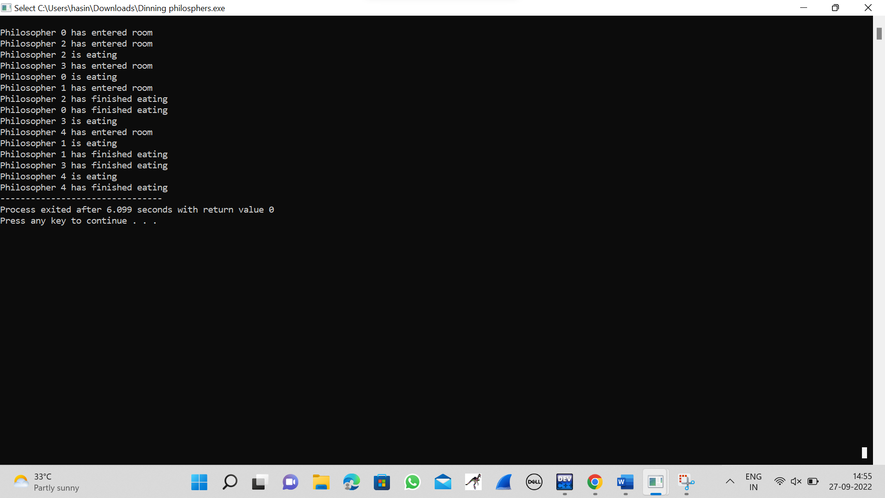

**5.PROGRAM**

#include<stdio.h>

int main( )

{

int bsize[10], psize[10], bno, pno, flags[10], allocation[10], i, j;

for(i = 0; i < 10; i++)

{

flags[i] = 0;

allocation[i] = -1;

}

printf("Enter no. of blocks: ");

scanf("%d", &bno);

printf("\nEnter size of each block: ");

for(i = 0; i < bno; i++)

scanf("%d", &bsize[i]);

printf("\nEnter no. of processes: ");

scanf("%d", &pno);

printf("\nEnter size of each process: ");

for(i = 0; i < pno; i++)

scanf("%d", &psize[i]);

for(i = 0; i < pno; i++)

for(j = 0; j < bno; j++)

if(flags[j] == 0 && bsize[j] >= psize[i])

{

allocation[j] = i;

flags[j] = 1;

break;

}

printf("\nBlock no.\tsize\t\tprocess no.\t\tsize");

for(i = 0; i < bno; i++)

{

printf("\n%d\t\t%d\t\t", i+1, bsize[i]);

if(flags[i] == 1)

printf("%d\t\t\t%d",allocation[i]+1,psize[allocation[i]]);

else

printf("Not allocated");

}

}

**OUTPUT**

